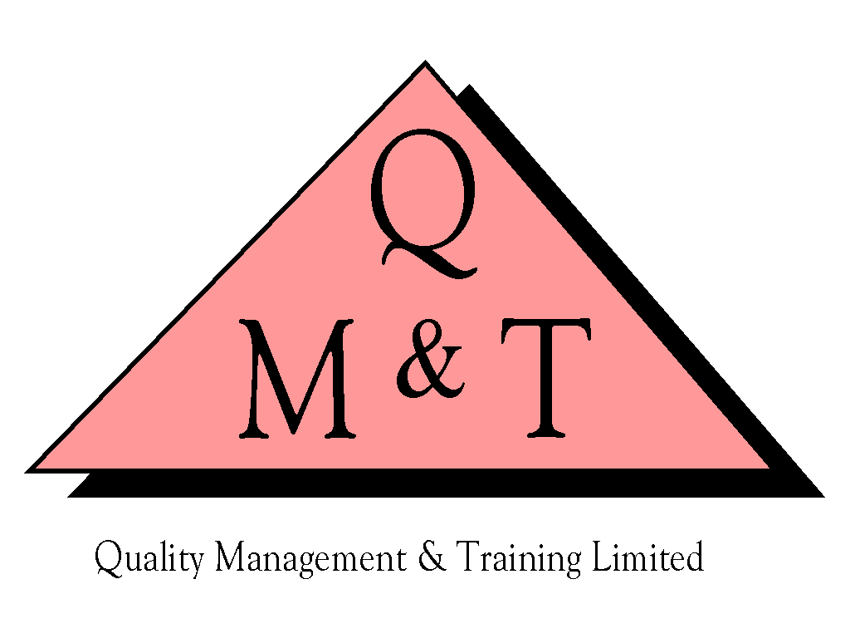
Quality Management & Training Ltd.
P.O. Box 172 - Guildford - Surrey - England - GU2 7FN

T: 01483 453511 - F: 01483 453512 - E: help@qmt.co.uk - W: www.qmt.co.uk

Privacy Notice
We respect and value the privacy of all our clients and will only collect and use personal data in a way that is consistent with our obligations and your rights under the law. We would never sell your personal data to third parties.
COMPANY INFORMATION
Company Names: Quality Management & Training (Publications) Limited (QMTP) & Quality Management & Training Limited (QMT)
Company Reg. Address: 31 Chertsey Street, Guildford, Surrey, GU1 4HD
QMTP VAT No.: 733 3954 25
QMT VAT No: 529 2907 26
QMTP Company Registration Number: 03141184
QMT Company Registration Number: 2495545
Telephone: 01483 453511
Email: help@qmt.co.uk

We are registered under the Data Protection Act 1998 and comply with all applicable data protection law whenever we handle your personal data.
The General Data Protection Regulation (GDPR) came into force on 25 May 2018.
Professional bodies that we have been approved as a provider of authorised training for their certified courses – such as the Chartered Quality Institute (CQI) and The International Register of Certificated Auditors (IRCA) – require us to inform them when our clients complete their courses or sit their exam for the certified courses. For further information on the CQI’s data processing policy, please follow this link https://www.quality.org/Approved-Training-Partners-Notice-of-Processing-Data-for-Delegates
We’re committed to protecting the privacy and the confidentiality of the personal information that our clients and provide us.
Our website has links to other websites. This privacy notice applies only to our website. We are not responsible for any use of your personal information that you provide to third party websites which may be accessed from this website.

The copyright and material contained in our website belongs to and remain the property of QMT & QMTP. Your access to it does not imply a license to reproduce, transmit and/or distribute this information in any form or by any means and you are not allowed to do so without our prior written consent. If you have any queries regarding our privacy policy then please contact help@qmt.co.uk
We may update this Privacy Notice from time to time. You are advised to review this Privacy Notice periodically for any changes.

